

HANDLING FLIGHT DISRUPTION

Solution Design Document Version:1

Document Information
Project Name: | HANDLING FLIGHT DISRUPTION
Prepared By: |  | Document Version No: | 1
Title: | Solution Document | Document Version Date: | May 24, 2024
Reviewed By: |  | Review Date:

Distribution List
Name | Email | Role

*

Document Version History
Version  Number | Version  Date | Revised By | Description | Filename
1 | May 24, 2024 |  | HANDLING FLIGHT DISRUPTION. | SolutionDocument.doc

- Introduction 4
  - Purpose 4
  - Scope 4
  - Definitions, Acronyms and Abbreviations 4
  - Summary of Existing Functionality 4
  - Requirement Details 4
  - Reference Documents 4
- GENERAL OVERVIEW AND DESIGN GUIDELINES/APPROACH 5
  - ASSUMPTIONS / CONSTRAINTS / STANDARDS 5
  - ALIGNMENT WITH TARGET ARCHITECTURE 5
- Architecture Design 5
  - Impact Analysis 5
    - Current Architecture 5
  - High Level Designs 5
  - Low Level Design 6
  - System Integration Design 7
    - External Interfaces 7
    - Internal Interfaces 7
    - External API 7
  - Security Design 7
  - Deployment Design 7
  - Tech Stack 7
- Non-Functional Requirements 8
  - Archiving 8
  - Logging 8
  - Auditing 8
  - Scalability 8
  - Fault Tolerance 8
  - System Management and Monitoring 8
  - User Role and access Management 8
- Appendices 8

Introduction

Purpose
This document’s purpose is to detail the functionality and process flow essential for managing flight disruptions effectively. Our primary objective is to create a re-accommodation engine for the operational window, focusing on Phase 1 from D-48 to 72 hours.
This document provides a clear and comprehensive guideline for all stakeholders involved, including the below.
  - Operations Control Centre (OCC) team,
  - AOCS,
  - CX,
  - RM,
  - Digital

Scope
Scope of our application, which is to handle disruptions and perform involuntary re-accommodation in specific scenarios.

1. Flight Cancellation:
When a flight is canceled in Jeppesen by OCC, the cancellation cascades to Navitaire, and re-accommodation is to be provided.

2. Flight Reschedule:
When a flight's ETD is changed in Jeppesen by OCC, the information cascades to Navitaire. Re-accommodation is required in case of misconnection, while customers have the option to choose an alternate flight via Plan B for all other scenarios.

Flights affected by a time change resulting in a departure delay of 2 or more hours or an advance departure by a minimum of 1 hour need to be addressed. The requirement includes accommodating impacted passengers on the best-suited alternate flights and informing customers of the change through suitable means.

Definitions, Acronyms and Abbreviations

Summary of Existing Functionality
- 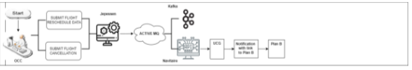

- User Action in Jeppesen System:
- A user cancels a flight or changes the departure time, causing either a delay or an advancement.

- Propagation to Apache Active MQ:
These changes are captured in the Jeppesen system and are subsequently sent to Apache Active MQ.

- Update in Navitaire and Kafka:
Apache Active MQ propagates the message to Navitaire application for updates in it.
· Simultaneously, the changes are published to Kafka.

- Notification to customer:
UCG application is triggered which sends notification message to customer with bitly link.
- Customer lands on Plan B page on website and can accept change, rebook flight, or opt for cancel and refund.

Requirement Details

Reference Documents
S.NO | Description | Provided By

GENERAL OVERVIEW AND DESIGN GUIDELINES/APPROACH

ASSUMPTIONS / CONSTRAINTS / STANDARDS

- OCC to update exception table whenever required before making changes in Jeppesen. System doesn’t enforce this.
- All external applications/servers like Kafka, GO-NOW (Navitaire), AD account validation, Sales force, UCG, Plan B are live and available.
- If specific TO flight is entered in exception table, then it is assumed that both FROM and TO flights have routing, same number of legs.
- Consider flights only in the window D-48 to D-72 hours before scheduled departure time for phase 1.
- Search alternate flights up to +(-) days manually configurable of impacted flight departure date for phase 1. – days field in configuration screen should be non-editable. Alternate flight search should be done only for current day and future flights. Previous day flights should not be considered.
- In case of reschedule, delay should be at least 2 hours or advance departure by minimum 1 hour for phase 1.
- Re-accommodation will be performed only from 6E-to-6E flights.
- No maximum limit on duration between two connecting flights while re-accommodating.
- If PNR has single journey, then entire journey to be re-accommodated based on origin and destination of journey.
- If PNR has multiple journeys, reaccommodate journey having impacted flight. If this causes misconnection with other journeys in PNR then re-accommodate on those journeys as well.

ALIGNMENT WITH TARGET ARCHITECTURE

- Tech stack and DB has been chosen as per architecture guideline.
- Integration between navitaire and offer engine through API.
- Proposed deployment platform is OCP.
- Code repository on Github
- Container based deployment through CICD
- Kafka Topic need to be subscribed.

Architecture Design

Impact Analysis
No impact.

Current Architecture
Offer engine is a new service.

High Level Designs

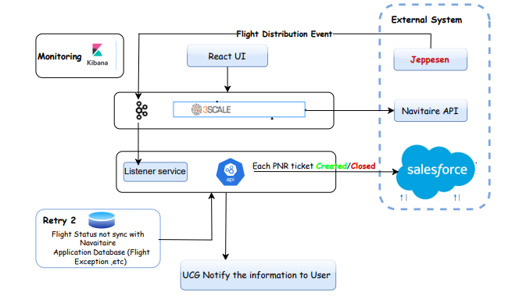

Backend Architecture
- RESTful API endpoints for client-server communication
- Dependency Injection for managing service dependencies.
- Integration with Navitaire API for flight-related functionalities like plan B
- Integration with Apache Kafka for event-driven communication between microservices

Frontend Architecture
- Component-based architecture following React best practices.
- State management using Redux tool kit.
- Redux-Saga or Thunk for handling side effects (if applicable)
- Reselect

  - Low Level Design

Phase 1: Restriction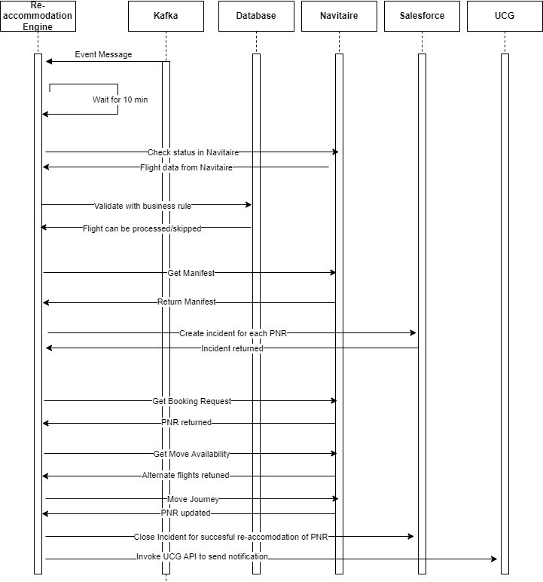

Phase 2: Other Changes

  - System Integration Design

3.4.1 Interfaces
- UCG
- Sales force
- Kafka Topic
- Navitaire Services

    - External API

SNO | API | Desc | Response
1 | https://dotrezapi.test.6e.navitaire.com/api/nsk/v2/manifest?Origin=MAA&Destination=DEL&BeginDate=2024-05-24&FlightType=0 | Manifest Request
2 | https://dotrezapi.test.6e.navitaire.com/api/nsk/v1/manifest/{{LegKey}} | Manifest LegKeyRequest
3 | https://dotrezapi.test.6e.navitaire.com/api/nsk/v1/booking/retrieve/byRecordLocator/{PNR} | Get booking
4 | https://dotrezapi.test.6e.navitaire.com/api/nsk/v3/trip/move/availability | GetMoveAvailabilityRequest
5 | https://dotrezapi.test.6e.navitaire.com/api/nsk/v1/bookings/{PNR} /journey | MoveJourneyBookingsRequest | 200
6 | https://uat-azucg.goindigo.in/UCGWebService/UCGWebService.svc | UCG | 200

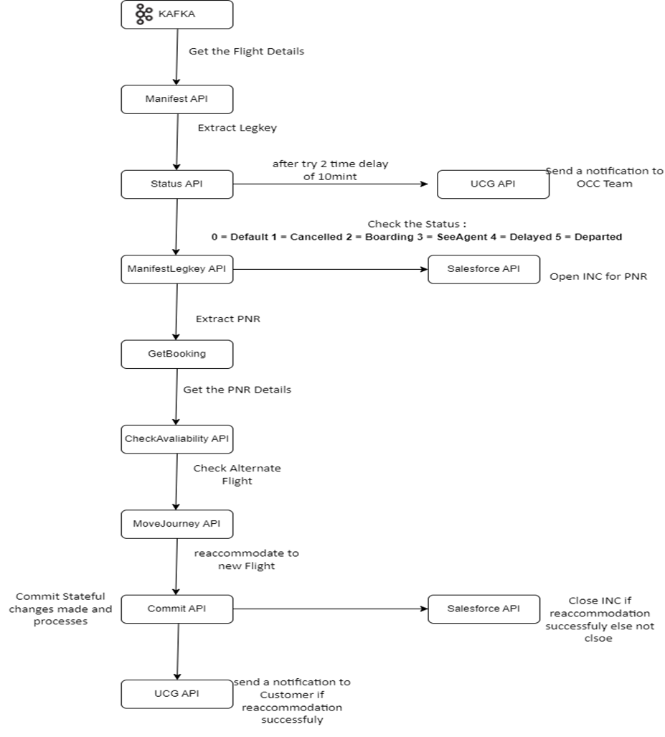

Security Design
- Azure AD Authentication
- API Authentication using JWT Token

Deployment Design

Continuous Integration/Continuous Deployment (CI/CD):
- Setup CI/CD pipelines using tools like Jenkins, Azure DevOps
- Automated testing (Sonar) and deployment to staging and production environments

Deployment Strategy

Deployment Environments:
- Development/QA/UAT Environment:
- Used for testing new features and changes before deployment to production
- Production Environment:
Deployment Process:
- Manual or automated deployment to staging environment for testing
- Pull Request Approval process for promoting changes to the production environment
- Rollback strategy in case of deployment failures

.

Tech Stack

Backend
- NET Core
- Entity Framework Core
- ASP.NET Core Web API
- Apache Kafka
- Navitaire API 4.5

Frontend
- React.js
- Redux
- Axios (for HTTP requests)

Database
- SQL Database
- Entity Framework Core for ORM

Messaging System
- Apache Kafka

Development Workflow:

Backend Development:
- Define API endpoints and data models.
- Implement business logic and data access layer.
- Integrate with Navitaire API for flight-related functionalities (Plan B)
- Integrate with Apache Kafka for asynchronous communication.
- Unit testing using xUnit or NUnit
Frontend Development:
- Setup React project structure.
- Develop UI components based on workflow, make sure to develop a shared component as needed
- Integrate with backend APIs.
- Implement client-side routing.
- Unit testing using Jest or React Testing Library
Integration:
- Integrate frontend with backend APIs.
- Test end-to-end functionality.
- Address any cross-origin resource sharing (CORS) issues.

Non-Functional Requirements

Archiving
Data will be archived after 180 days. Purged after 240 days.

Logging
Kibana log will be used.

Auditing
Changed audited and histories are maintained in a separate table.

Scalability
Data extraction API will be scheduled. Application logic to support scalability of Data processing API to support concurrent executions.

Fault Tolerance
A mail will be sent to the respective team and business user teams in case of any failure.

System Management and Monitoring
It can be monitored by the OCP team.

User Role and access Management
Role access to Restrictions UI to be managed as a part of application development. No

Appendices
NA

